The card 1st.
The weather is … in December\ January\ February.
It`s … .
The weather like … in December\ January\ February.
December, January, February

1)_________________________________ are the coldest (самые холодные) months. 2)_________________________________________________________________________3)_________________________________________________________________________4)___________________________________________________________________________________________________________________________________________________

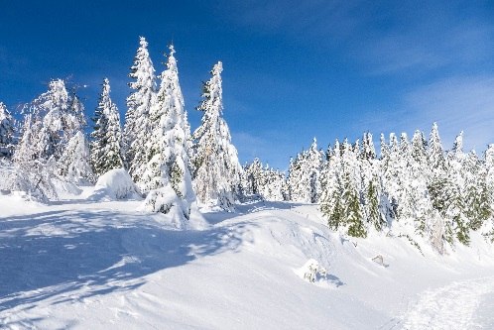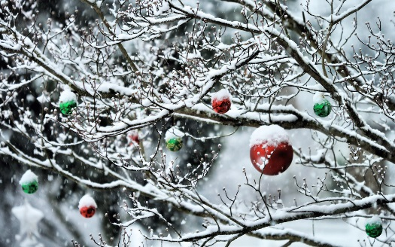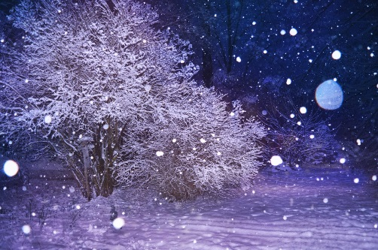

The card 2nd

The weather is … in March\ April\ May.
It`s … .
The weather like … in March\ April\ May.
March, April, May.

1)_________________________________ are the sunniest (самые солнечные) months. 2)_________________________________________________________________________
3)_________________________________________________________________________4)_________________________________________________________________________
__________________________________________________________________________

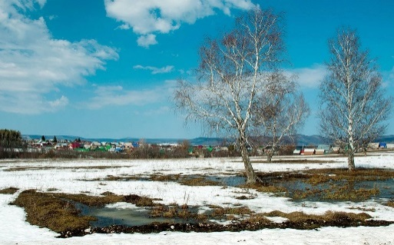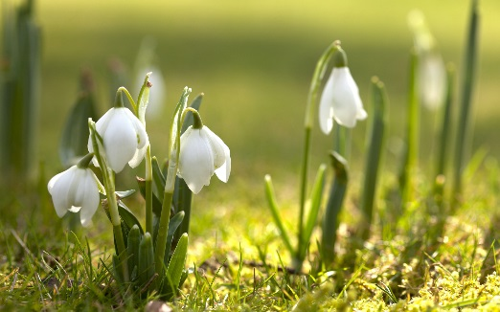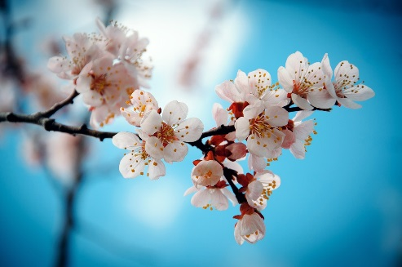

The card 3rd
The weather is … in June\ July\ August.
It`s … .
The weather like … in June\ July\ August.
June, July, August.

1)_________________________________ are the hottest (самые жаркие) months. 2)_________________________________________________________________________3)_________________________________________________________________________4)___________________________________________________________________________________________________________________________________________________

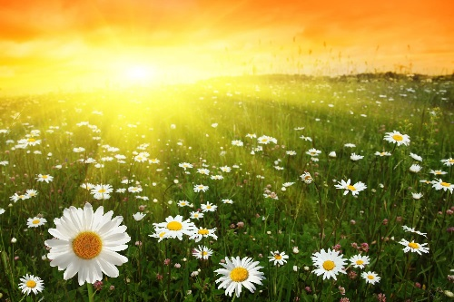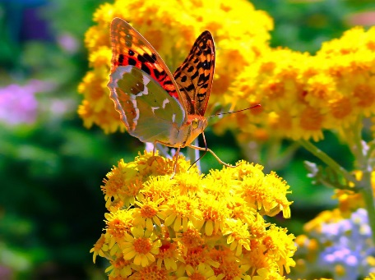

The card 4th
The weather is … in September\ October\ November.
It`s … .
The weather like … in September\ October\ November.
September, October, November.

1)_________________________________ are the rainiest (самые дождливые) months. 2)_________________________________________________________________________3)_________________________________________________________________________4)___________________________________________________________________________________________________________________________________________________

