Hetty's Journey to Europe

Come and travel with me around Europe, friends.
Be careful in the way. Perform tasks carefully. Lucky road!

1 task
What`s the time? Hetty has visited many countries and cities. Help him write the time on the clocks.
1. Paris  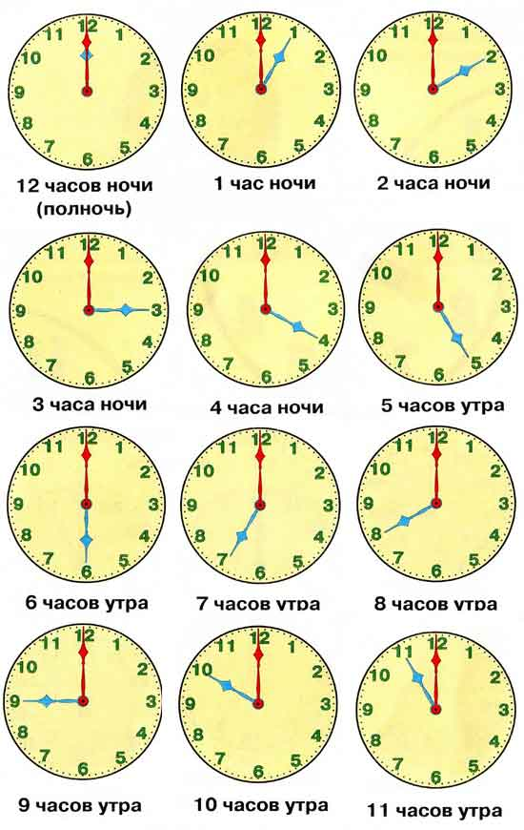  It`s six o`clock. | 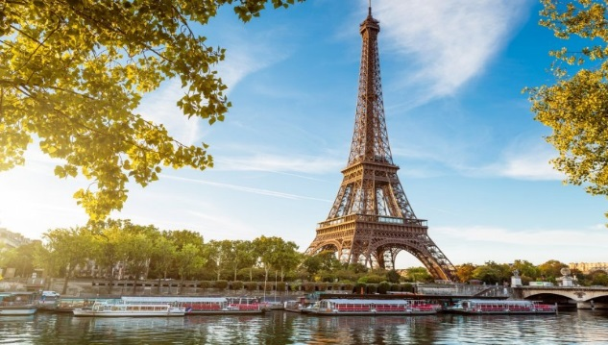
2. London | 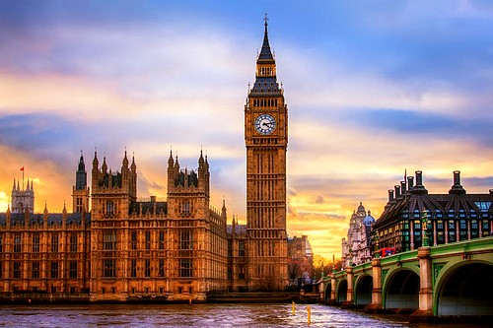
3. Rome [ rəʊm ]  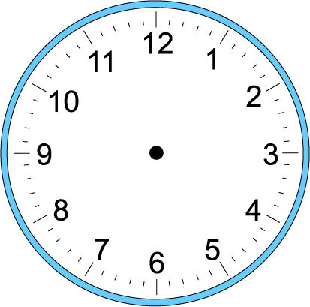 | 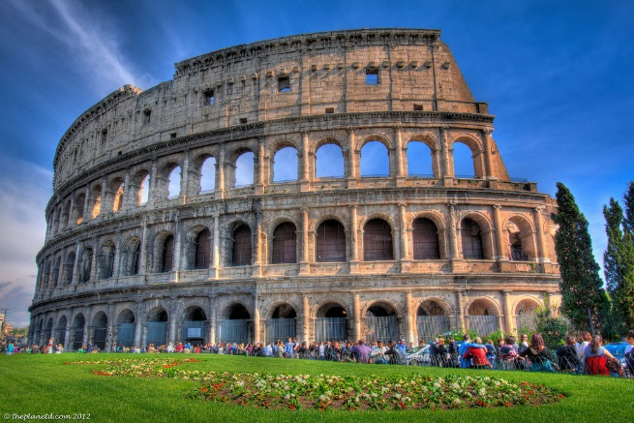
4. Venice [ ˈvenɪs ]  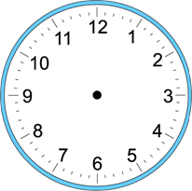 | 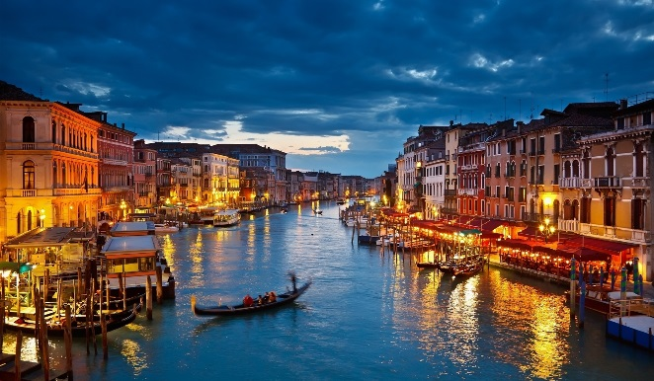
5. Berlin [ bɜːˈlɪn ] | 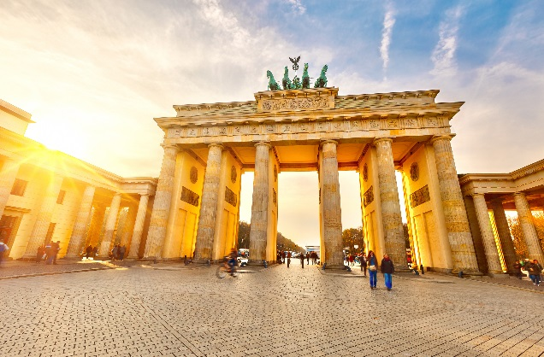
6. Kiev [ ˈkiːef ] | 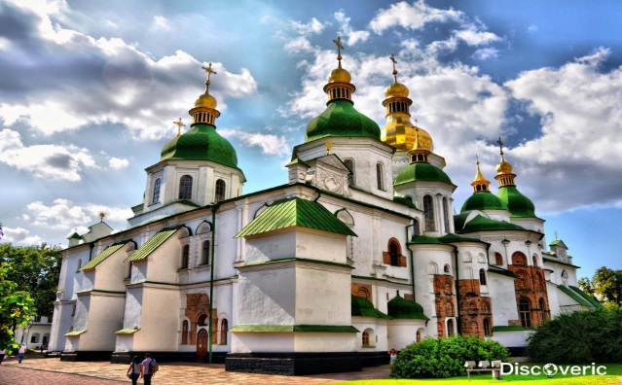

2 task
Write the time in words:
1. Hetty woke up in Kiev at half past eight. (8:30)
2. Hetty arrived in Berlin at _______________________ . (2: 35)
3. He had lunch at ________________________________. (12:15)
4. He played tennis at ___________________________ in London. (2:05)
5. Hetty was having supper at ______________________. (7:00)
6. He went on an excursion in Rome at ______________________. (3:30)
7. He rode on horses at _____________________________. (9:00)
8. Hetty usually has breakfast at ________________________. (9:15)
9. He takes a shower at ___________________________. (10:00)
10. He goes to bed at _______________________________. (10:30)
Prompts:
1. Hetty visited … . At six o`clock he has been to Paris.

2. - At half past eight Hetty woke up in Kiev.
- At twenty-five to three Hetty … .
- At a quarter past twelve Hetty … .
- At five past two Hetty … .
- At half past three Hetty … .
- At nine Hetty … .

Johnny`s Journey to America

Come and travel with me around America, friends.
Be careful in the way. Perform tasks carefully. Lucky road!
1 task
What`s the time? Johnny has visited many countries and cities. Help him write the time on the clocks.
1.Brasilia [ brəˈzɪlɪə ]  ____________ It`s three o`clock  ______________________  ______________________ | 
2. Mexico City [ˈmeksɪkəʊ ˈsɪti ] | 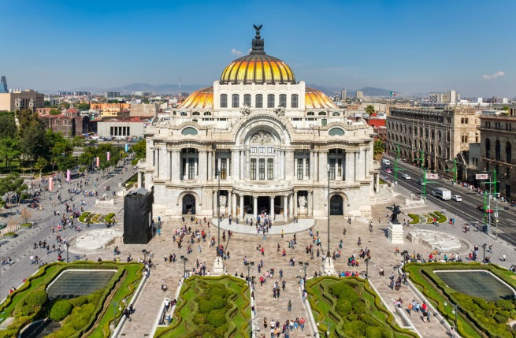
3. Ottawa [ ˈɒtəwə ] | 
4. Washington [ ˈwɒʃɪŋtən ] | 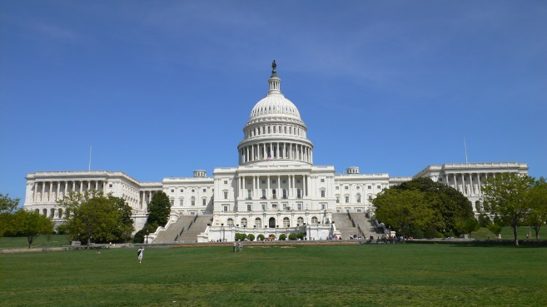
5. Chicago [ ʃɪˈkɑːgəʊ ] | 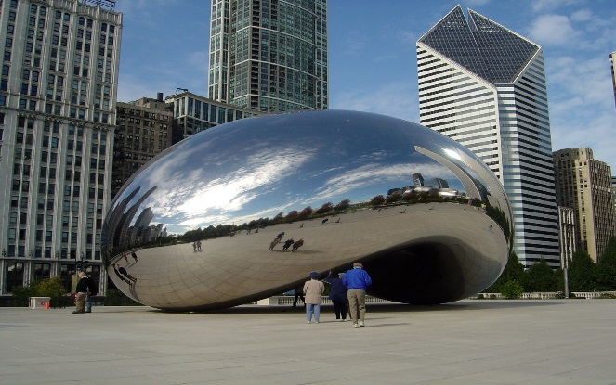
6. Panama [ ˈpæn.ə.mɑː ] | 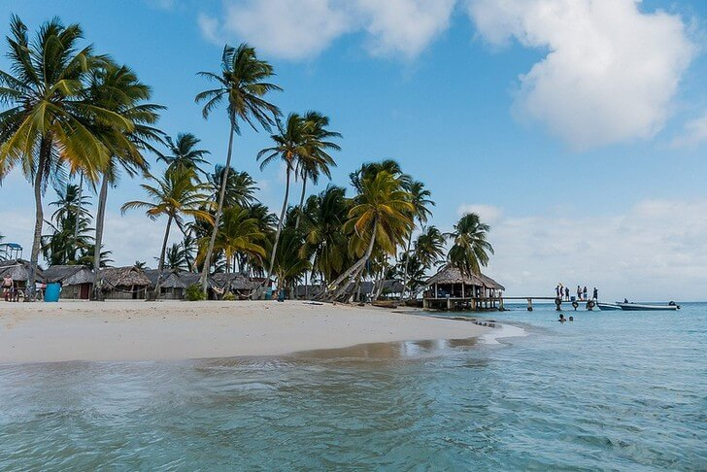

2 task
Write the time in words:
1. Johnny woke up in Panama at half past eleven. (10:30)
2. Johnny arrived in Washington at _______________________ . (6:15)
3. He had lunch at ________________________________. (12:10)
4. He played football at ___________________________ in Mexico. (11:45)
5. Johnny was having supper at ______________________. (6:00)
6. He went for a walk in a park _________________________. (11:25)
7. He visited a restaurant _____________________________. (9:00)
8. Johnny usually has breakfast at ________________________. (6:45)
9. He takes a shower at ___________________________. (7:00)
10. He goes to bed at _______________________________. (9:30)
Prompts:
1. Johnny visited … . At six o`clock he has been to Brasilia.
2. - At half past eleven Johnny woke up in Panama.
- At a quarter to twelve Johnny … .
- At six o`clock Johnny … .
- At twenty-five past eleven he … .
- At eight o`clock he … .
- At half past nine Johnny … .

Jane`s Journey to Asia
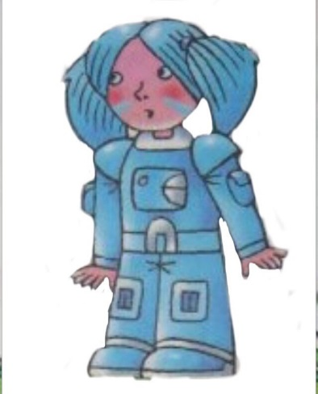
Come and travel with me around Asia, friends.
Be careful in the way. Perform tasks carefully. Lucky road!

1 task
What`s the time? Jane has visited many countries and cities. Help her write the time on the clocks.
1. Beijing [ ˌbeiˈdʒɪŋ]  It`s ten o`clock. | 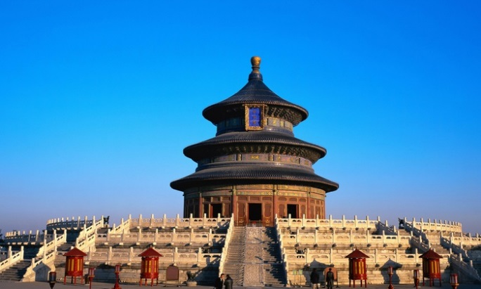
2. Jakarta [dʒəˈkɑːtə ] | 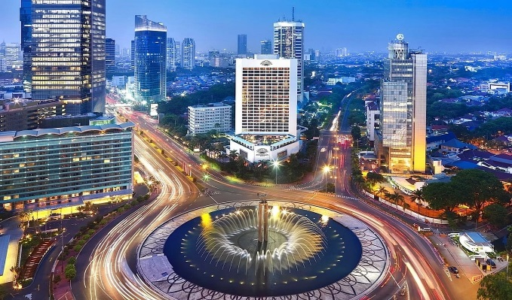
3. Ankara ['æŋkərə ] | 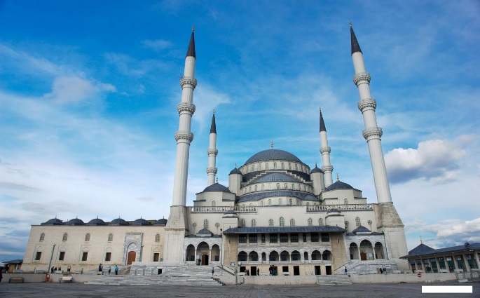
4. New Delhi [njuː ˈdeli ] | 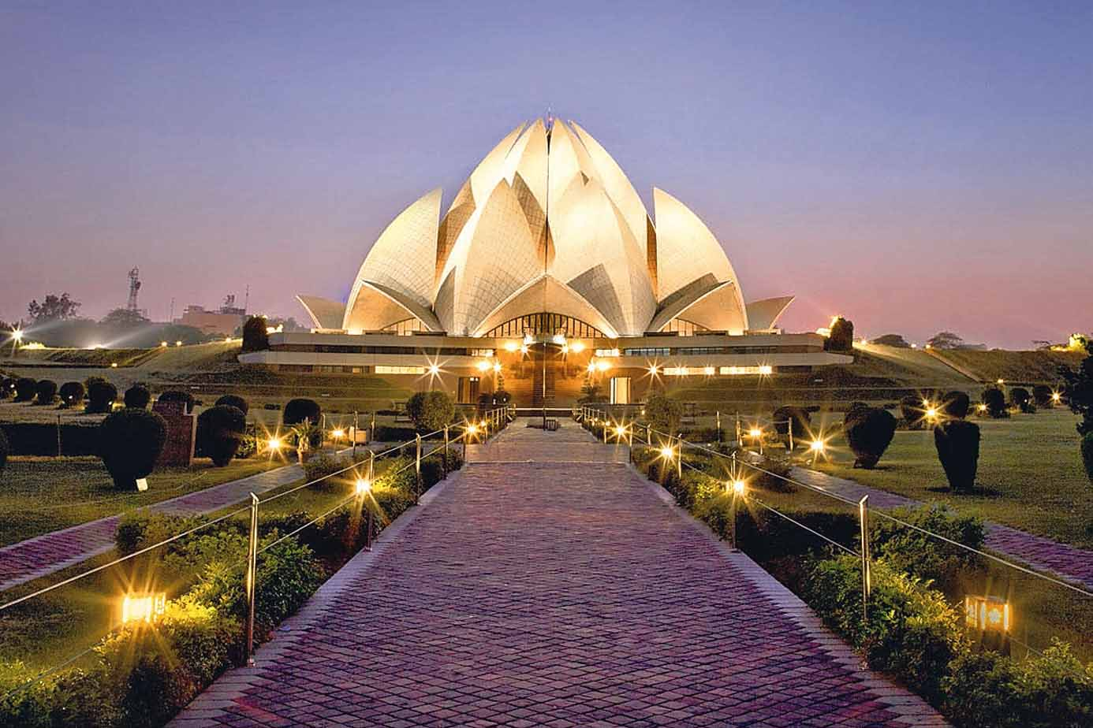
5. Tokyo [ˈtəʊkjəʊ ] | 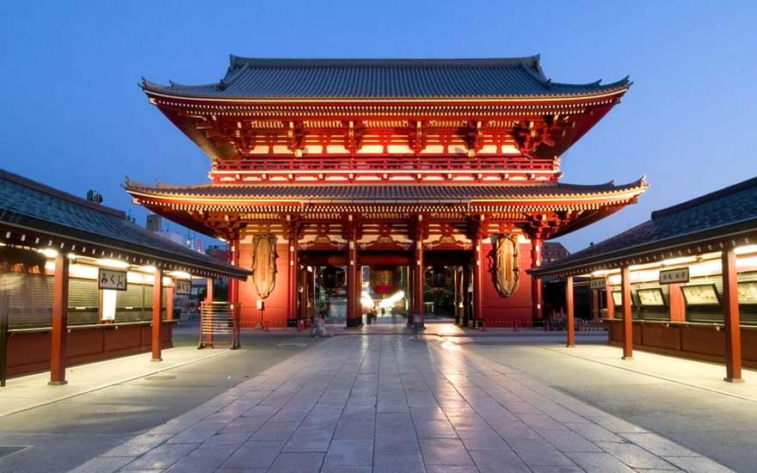
6. Astana [ æstæ'nɑː ] | 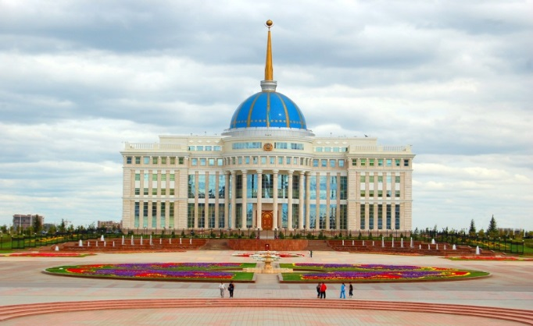

2 task
Write the time in words:
1. Jane woke up in Astana at half past seven. (7:30)
2. Jane arrived in Tokyo at _______________________. (3:15)
3. She had lunch at ________________________________. (11:50)
4. She played basketball at ___________________________ in Ankara. (2:30)
5. Jane was having supper at ______________________. (9:00)
6. She went for a walk in a forest _________________________. (4:00)
7. She visited a café [ ˈkæf.eɪ ] _____________________________. (10:25)
8. Jane usually has breakfast at ________________________. (7:45)
9. He takes a shower at ___________________________. (8:30)
10. He goes to bed at _______________________________. (11:30)
Prompts:
1. Jane visited … . At ten o`clock he has been to Beijing.
2. - At half past seven Jane woke up in Astana.
- At a quarter past three Jane … .
- At half past two she … .
- At four o`clock Jane … .
- At twenty-five past ten she … .
- At half past eight Jane … .

